Research Report
Data Science 214 AF Project 2024 : ShopAlot
Group 22 members:
- Lydia Laubscher 27357570
- Tiaan Viviers
- Abraham de Villiers

Problem Statement
ShopAlot is a general online store operating across all nine provinces of South Africa. Customers create profiles to make purchases, providing data such as age and province. ShopAlot collects historical data on clients, as well as various "in-store" variables are recorded during each client visit and purchase.

The primary goal of this project is to:
- Explore and analyze the provided dataset to understand the factors influencing the total amount spent by clients.
- Build a predictive model to accurately forecast `Sales` based on the available variables.
- Interpret the significant factors that influence `Sales` to provide actionable insights.
- Recommend strategies for ShopAlot to increase sales and improve customer engagement.
Understanding the drivers behind customer spending is crucial for ShopAlot to:
- Optimize marketing and advertising efforts.
- Personalize customer experiences.
- Potentially make more money.
- Improve customer retention and loyalty programs.

Exploratory Data Analysis
Univariate:
Sales: The distribution is right-skewed. This suggests that most customers spend small amounts, but few spend significantly more, leading to potential outliers.
AvgSpend: This distribution is right-skewed, indicating that a small number of customers have a significantly higher average spend. This may be worth investigating for segmentation of high-value customers.
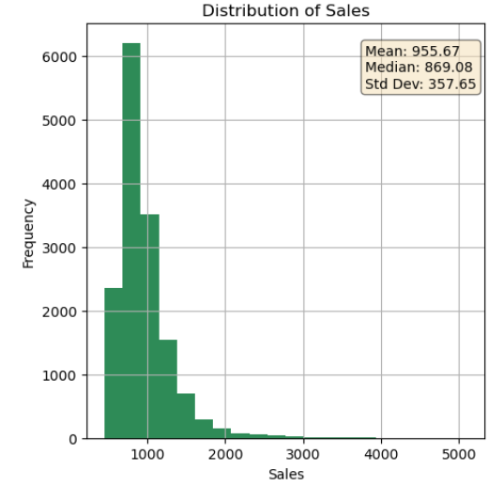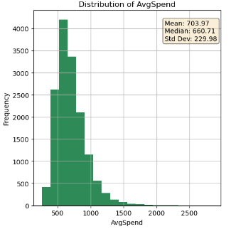
ProfileInMonths: This variable is right-skewed. ShopAlot has a large number of newer customers.
Online: The distribution is normal and centered around 45 minutes, meaning most customers spend a reasonable amount of time on the website before logging off.
NumPrevOrders: The distribution shows multiple peaks, suggesting multiple groups of customers.
AgeInMonths: The distribution is nearly symmetric and centered around ~37 years old. This indicates a normal distribution for the age of clients, with no significant outliers.
POSR (Point-of-Sales Ratio): The distribution has multiple peaks, suggesting that different customers may have varying levels of responsiveness to advertisements.
OPR (Order-Purchase Ratio): This distribution clearly has two distinct groups: those with a higher likelihood to complete a purchase after adding items to their basket, and those with a lower likelihood.
Discount: Most customers receive no discounts, with very few instances of higher discounts being offered (concentrated near 0%).
Distribution of Month: ShopAlot experiences a strong seasonality in sales, particularly toward the end of the year.
Distribution of Subscribed: The majority of customers seem to prefer Daily and Monthly communication.
Distribution of ShippingOption: Implication: Customers value quicker (Express) shipping options but may be less inclined to pay extra for Premium shipping.
Distribution of Platform: Implication: ShopAlot's website is primarily accessed via desktop, indicating that the desktop user experience should be a key focus.
Distribution of Payment: Customers show a clear preference for Credit Card and EFT. Optimizing the payment process for these two methods could improve customer satisfaction.
Distribution of Ad_1: The majority of customers did not interact with Ad_1 (social media targeted ad), with fewer customers exposed to it.
Distribution of Ad_2: Ad_2 (the "frequently bought together" ad) was shown to more customers than not, with the majority of customers being exposed to this advertisement.
Distribution of Ad_3: Given its high visibility, Ad_3 might be an important driver of sales for popular or new products.
Distribution of SocialMedia: Instagram is the most frequently used social media channel, followed by Facebook and then Twitter.
Distribution of ShippingPayment: Almost all customers opt for Free shipping, with very few choosing to pay for shipping.
Distribution of Category: Electronics and clothing are strong drivers of sales.
Distribution of DayOfWeek: There is a clear trend toward increased sales during weekends, particularly on Sundays.
Distribution of Province: Focusing marketing and logistical efforts in Gauteng and Western Cape could yield the highest return.
Multivariate
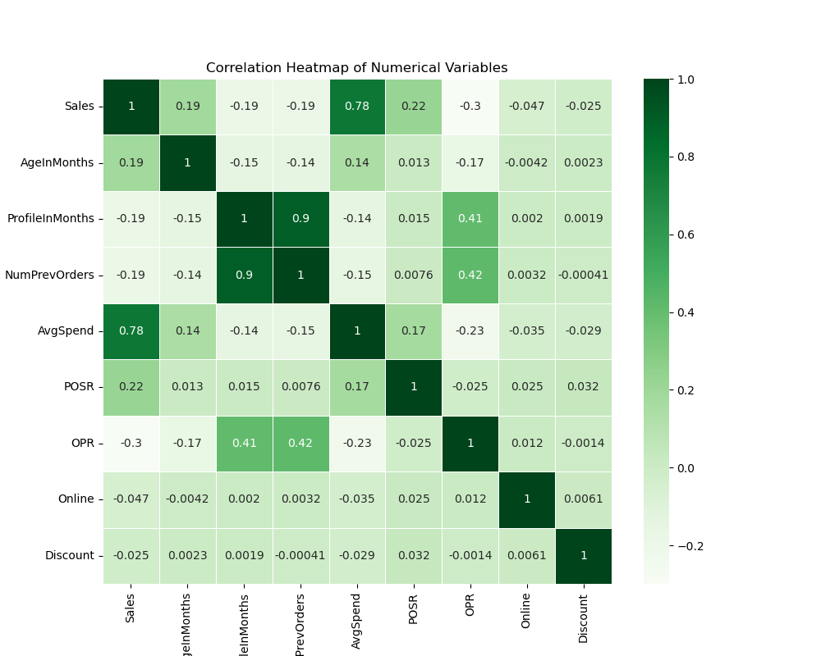
NUMERICAL:
Strong Correlation:
AvgSpend vs. Sales:
A strong positive correlation of 0.78 indicates that customers who have a higher average spend on previous orders tend to spend more on future orders as well. This is a key predictor of sales.
Multicollinearity:
NumPrevOrders vs. ProfileInMonths: A very high correlation of 0.90 shows that the number of previous orders increases as the profile age increases, which makes sense as older profiles are more likely to have placed more orders.
OPR vs. ProfileInMonths and OPR vs. NumPrevOrders: Both show a correlation of around 0.40, indicating that customers with older profiles or more previous orders tend to have higher OPR (Order-Purchase Ratio).

CATEGORICAL:
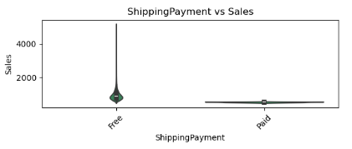
ShippingPayment vs. Sales:
There’s a significant difference between Free and Paid shipping options. Although most customers opt for Free shipping, those who choose to pay for shipping tend to spend significantly more. ShopAlot could explore offering premium shipping options with added value to promote some higher spending.
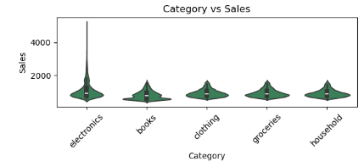
Category vs. Sales:
Electronics drive the highest spending, while other categories like Books and Household may need more attention to boost sales. ShopAlot should focus on optimizing the electronics category for maximum profitability.

Data Processing
Missing Values:
In our dataset, we identified missing values in the Subscribed and SocialMedia columns. Since both are categorical variables, we opted to handle the missing values by filling them with appropriate categories that make sense based on the context.
- `Subscribed`: We filled missing values with "Not Subscribed". We assumed that if a customers subscription status is missing, they are not subscribed to any promotional emails. This ensures that the missing values are handled in a way that preserves the categorical nature of the variable and aligns with business logic.
- `SocialMedia`: We filled missing values with "None", indicating that customers were not contacted via any social media platform. This choice ensures that we capture the customers who were not influenced by social media.

Handling of Outliers:
To ensure that outliers don’t disproportionately affect the model while preserving meaningful information, we chose to apply capping at the 95th percentile for 3 variables.
Variables Capped: `ProfileInMonths`, `Online`, and `Discount` were capped. By capping these variables, we maintain the integrity of the data while mitigating the potential distortion caused by outliers.
Variables not Altered:
- `Sales`: Outliers in sales likely represent high-value transactions or important customer segments that could provide valuable insights.
- `AvgSpend`: High average spenders could represent premium customers. We believe there is valeuble insights in this data.

Interaction terms:
`Discount_AvgSpend`:AvgSpend was identified as one of the strongest predictors of Sales (with a correlation of 0.78). By interacting it with Discount, we aim to capture the potential impact of discounts on customers who tend to spend more on average. This interaction can help reveal whether high-value and low-value customers are more or less influenced by discounts.
Transformations:
We observed that AgeInMonths exhibited a parabolic relationship with Sales, which indicated a non-linear pattern. To linearise this relationship and make it easier for the model to capture, we applied a square root transformation.

Dummy Encoding:
The following categorical variables were encoded:
`Subscribed`, `ShippingOption`, `Platform`, `Payment`, `Ad_1`, `Ad_2`, `Ad_3`, `SocialMedia`, `Shipping`, `PaymentCategory`, `DayOfWeek`, `Province`.
Additionally, we mapped the Month variable into seasons (`Summer`, `Autumn`, `Winter`, `Spring`).

Train Test Split:
We opted for a classic 75/25 train-test split. We feel there is enough training data in 75% of the original data frame that we can have a slightly bigger testing set at around 25%, rather than the usual 20% or 10%

